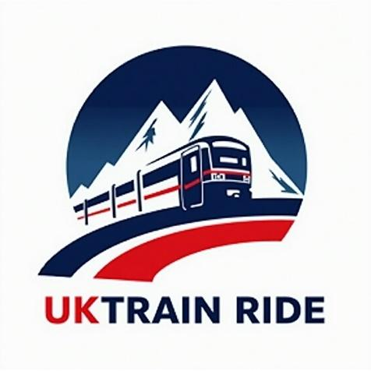 | Summary Report  Google Data Analyst Specialist  CLS ONL2_DAT1_G2 |  | 
Sponsorship
Ministry of Communications and Information Technology
(MCIT) Egypt

Digital Egypt Pioneers Initiative
DEPI

Project Idea 6: (Outstanding)
UK Train Rides.

Supervised by
Dr. Yasser A. Rahman
Prepared by: Elite Team
Ahmed Hussein Ali Mustafa
Fatma Alzahraa Galal Abd-elsalam Soliman
Heba Tallah Talaat Ezzat Ibrahim
Kareman Mohamed Mahmoud Awad

 | Summary Report  Elite Team |  | 

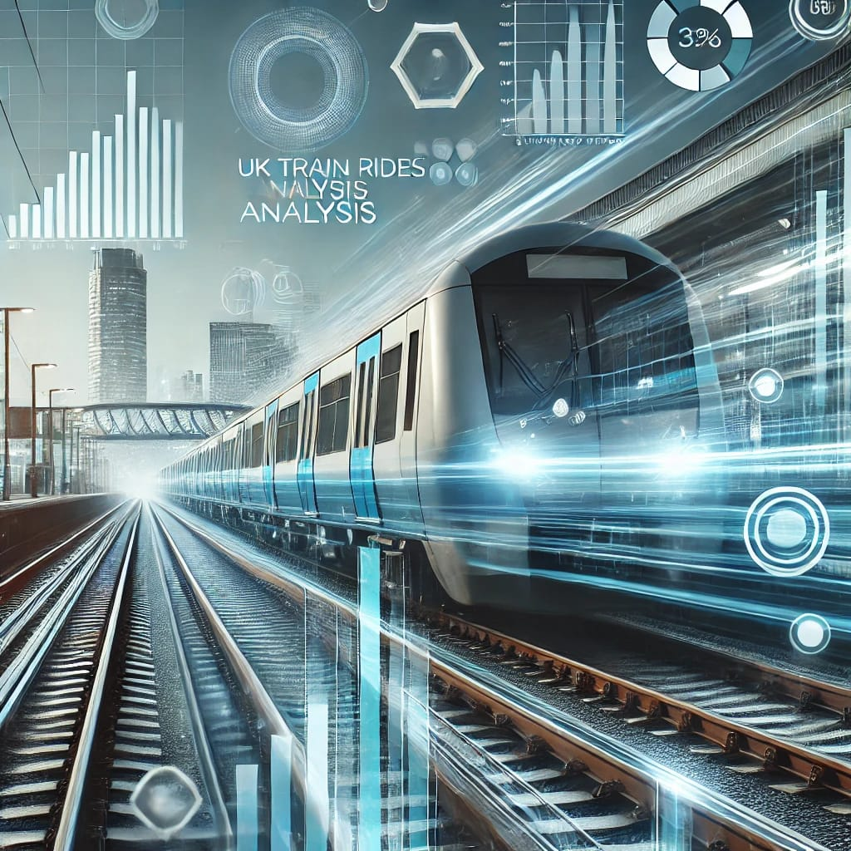

UK Train Rides Analysis Summary Report

Introduced by:
Elite Team

Introduction:

The UK railway network plays a crucial role in transportation, connecting cities and facilitating daily commutes. Our analysis, based on train ticket data from January to April 2024, focuses on operational efficiency, financial performance, customer behavior, and route analysis. The goal is to uncover key insights that can optimize pricing strategies, enhance customer experience, and improve operational performance.

Results & Insights:

- Operational Efficiency
- Financial Analysis

Customer Behavior

Route Analysis

Demographic Insights

1. Operational Efficiency:
This report provides an analysis of UK railway performance, focusing on journey statistics, punctuality rates, delay reasons, and refund requests. The goal is to identify operational inefficiencies and recommend improvements to enhance service reliability and passenger satisfaction.

Key Performance Metrics
- Total Journeys: 31,653
- On-Time Journeys: 27,481 (86.82%)
- Delayed Journeys: 2,292 (7.24%)
- Cancelled Journeys: 1,880 (5.94%)

Top Five Popular Stations by Journey Volume
- Manchester Piccadilly – 5,650 journeys
- London Euston – 4,954 journeys
- Liverpool Lime Street – 4,561 journeys
- London Paddington – 4,500 journeys
- London Kings Cross – 4,229 journeys
The high journey volume at these stations highlights their strategic importance in the railway network. Enhancing service reliability at these locations should be a priority.
Delay reasons and their impact on refund requests:
Reason | Delayed Journeys | Refund Requests | Refund Rate (%) | Max Delay (Minutes) | Cancelled Journeys
Weather Conditions | 927 | 0 | 0% | 59 | 445
Technical Issues | 472 | 316 | 66.95% | - | -
Signal Failure | 451 | 60 | 13.30% | - | -
Staffing Issues | 355 | 123 | 34.65% | - | -
Traffic Congestion | 87 | 47 | 54.02% | - | -

Delay reasons:
1. Weather Conditions:
- Recommendation: Improve weather forecasting and infrastructure resilience to minimize disruptions, particularly at high-traffic stations like Manchester Piccadilly and London Euston.
2. Technical Issues:
- Recommendation: Implement proactive maintenance strategies and predictive analytics to identify and resolve technical issues before they impact service.
3. Signal Failure:
- Recommendation: Upgrade signaling infrastructure and implement automated monitoring systems to detect failures in real time.
4. Staffing Issues:
- Recommendation: Optimize staff scheduling and recruitment strategies to prevent shortages, especially during peak hours.
5. Traffic Congestion:
- Recommendation: Improve coordination with city traffic management authorities and adjust scheduling to mitigate congestion effects.

Conclusion & Recommendations
- Enhance Predictive Maintenance: Implement AI-driven predictive maintenance tools to reduce technical failures and signal issues.
- Invest in Infrastructure Resilience: Upgrade tracks, stations, and signals to withstand adverse weather conditions.
- Improve Staff Management: Adopt workforce planning strategies to mitigate staffing-related delays.
- Increase Passenger Communication: Provide real-time journey updates via mobile apps and station displays.
- Optimize Traffic Management: Introduce automated traffic monitoring systems to improve scheduling and reduce congestion.

By implementing these recommendations, UK Railway can significantly enhance operational efficiency, minimize delays, and improve passenger experience.

2. Financial Analysis

1. Incoming Revenue:
- Total incoming revenue is £741,921, but we have already refunded £38,702 to some customers whose journeys were delayed or cancelled, while the remaining refunds amount to £133,568 (£100,649 delayed + £32,919 cancelled)
- On-time journeys represent the majority, with 569,651 completed without any refunds, contributing 76,78% of the total net journeys.
- Delayed journeys accounted for £126,814, with £26,165 refunded, reducing the net total to £100,649.
- Cancelled journeys were the least frequent, with £45,456 incoming and £12,537 refunded, leaving £32,919 net journeys.
- The total number of incoming journeys was £741,921, with £38,702 refunded, resulting in £703,219 net journeys.

Conclusion & Recommendations
- According to the Conservatism Principle, the amount of £133,568 should not be recognized as “Actual revenue” but should be recorded as “Deferred revenue” until customers request a refund of their advanced payments.
- Delayed journeys (17.09%) resulted in substantial refunds; strategies to improve punctuality could help minimize losses.
- Cancelled journeys (6.12%) also contributed to refunds. Reviewing cancellation reasons and implementing preventive measures can enhance service reliability.
- The high percentage of on-time journeys (76.78%) indicates strong operational efficiency. However, continuous monitoring is essential to maintain this performance.

2. Payment methods breakdown
- Credit Card payments account for the highest number of transactions, £18,733 and generate the highest revenue £460,480, contributing 65.48% of total revenue.
- Contactless payments are the second most used method, with 10,623 transactions, generating £214,516, which represents 30.50% of the total revenue.
- Debit Card payments have the lowest usage, with only 1,179 transactions, generating £28,223, contributing 4.01% to the total revenue.
Conclusion & Recommendations
- Contactless payments are becoming increasingly popular and should be further promoted to enhance customer convenience and transaction speed.
- Credit Card transactions remain the primary revenue driver, and any initiatives aimed at optimizing this payment method could further boost revenue.
- Debit Card transactions are relatively low; strategies to encourage more usage, such as offering incentives, could be explored.

3. Purchase type breakdown

Key Insights
- Online transactions account for 59.31% of total transactions and generate the highest revenue (£374,540), indicating a strong preference for digital payments.
- Station transactions contribute 40.68% of the total transactions, generating £328,679, showing that physical locations remain a significant revenue source.
- The total revenue generated from all payment methods is £703,219, with a fairly balanced distribution between online and station sales.

Conclusion & Recommendations
- Online payments dominate, highlighting the importance of maintaining a seamless and secure digital payment system. Further enhancements, such as promotional discounts for online purchases, could boost digital adoption.
- Despite the rise of online payments, station transactions still contribute significantly. Ensuring efficient payment processing at stations will help maintain a smooth customer experience.
- Continuous monitoring of transaction trends will be valuable in optimizing both online and station-based payment strategies for maximum revenue growth.

4. Ticket Class

Key Insights:
- Revenue Contribution: Standard Class generates (£560,184) 79.66% of total revenue , while First Class contributes (£143,035) 20.34%.
- Transaction Volume: Standard Class accounts for 90.35% of total transactions (27,590), whereas First Class represents only 9.64% (2,945).
- Revenue per Transaction: First Class yields £48.57 per transaction, significantly higher than Standard Class at £20.30 per transaction.

Conclusion & Recommendations:
- Premium Class Strategy: Enhance First Class offerings (e.g., exclusive services, loyalty perks) to increase transaction volume.
- Targeted Marketing: Develop upselling strategies to encourage Standard Class passengers to upgrade to First Class.

3. Customer Behavior
- Most Crowded Stations: Birmingham New Street (7,742 arrivals), Manchester Piccadilly (5,650 departures).
- Ticket Type Preferences: Advance tickets are the most popular (55.46% of total passengers).
- Purchase Behavior: Most passengers prefer buying tickets in advance for lower prices.

Most Crowded Stations Manchester Piccadilly has the highest departure traffic (5650 departures), indicating that this station is a major origin point for passengers.
Birmingham New Street is the most crowded arrival station (7742 arrivals), highlighting its importance as a key destination for intercity travelers.
Ticket type distribution, a large share of Advance tickets (55.48%) indicates that customers are price-sensitive and tend to book earlier to secure cheaper fares or better availability..
Purchase time (hourly) against ticket prices suggests a fluctuation throughout the day.
o Peak prices during early morning(6 AM) or late evening (4PM-6PM) if demand is higher.
o Lower prices at off-peak times (e.g., midday), encouraging travelers with flexible schedules to book then.
Railway Lines with Highest Passengers a highlighted visualization indicates which routes (e.g., Manchester Piccadilly to Liverpool Lime Street (4628 trip), London Euston to Birmingham New Street (4209 trips) , etc.) carry the largest passenger volumes.
Overall Insights and Recommendations
- Peak Stations: Manchester Piccadilly to Liverpool Lime Street routes handle the greatest volume, suggesting a focus on improving facilities and service quality at these hubs.
- Ticket Pricing Strategy: Since Advance tickets are popular, consider dynamic pricing and targeted marketing to capture even more early-bird customers.
- Time-Based Demand: Identify peak purchasing hours and plan staffing or system capacity accordingly (e.g., ensuring ticketing website/server capacity during spikes).
- Marketing Opportunities: Promote quieter routes or times with special offers to distribute demand and enhance utilization of less crowded trains.

Conclusion
These findings illustrate how passengers behave in terms of when they buy tickets, which stations they use most, and what types of tickets they purchase. By applying these insights, railway companies can:
- Optimize pricing to match demand.
- Enhance customer experience through better scheduling and resource allocation.
- Develop targeted promotions to increase ridership during off-peak times.

4. Route Analysis:
Most Popular Route:
- Manchester Piccadilly → Liverpool Lime Street (4,628 trips).

Highest Revenue Routes:
- London Kings Cross → York (183,459£) this route has more than 7 journeys a week with 60 journeys and 3930 tickets from 16/12/2023 to 6/4/2024 with total sales of 183459£ which is most profitable revenue that is about 24.7% from all UK rail way sales for the same period.
- Liverpool Lime Street → London Euston (113,451£)
- London Paddington → Reading (65,467£)

Lowest Revenue Routes:
- London Euston→ Oxford with 16 rides, total revenue 41£ and 1 trip
- Manchester Piccadilly→ Warrington with 15 rides, total revenue 53£ and 1 trip
- Birmingham New Street→ Wolverhampton with 32 rides, total revenue 60£ and 1 trip
- Edinburgh Waverley → London Kings Cross: This route has more than two journeys a week with 43 journeys from 3/1/2024 to 26/4/2024 with total sales of 2093£ which is very low revenue

Most delayed route:
- Liverpool Lime Street → London Euston with total revenue £113,451 and (11 trips)

Routes duration and their revenue: The most profitable route
- London Kings Cross → York: 1Hour and 30 Minutes with total revenue 183,459 and 60 trips
- While the most popular route
- Manchester Piccadilly → Liverpool Lime Street: (30 Minutes) with total revenue 17316£ and 64 trips

Peak revenue hours:
- 6AM has a total revenue 110712£ with number of tickets (1911 trips)

5. Demographic Insights:
- Rail Card Usage:
20,921 passengers traveled without a rail card.

- Preferred Payment Methods:
Credit card payments accounted for 60.46% of transactions.

Key Findings & Recommendations:
1. Improve Delay Management by investing in infrastructure and contingency planning.
2. Optimize high-frequency, low-revenue routes by adjusting pricing or reducing frequency.
3. Enhance Peak Hour Pricing Strategies through dynamic pricing models.
4. Boost Online Ticket Sales through digital marketing and promotions.
5. Improve Revenue on Longer Journeys by offering premium experiences or advance booking discounts.

Conclusion:
Our analysis provides valuable insights into train punctuality, revenue trends, customer preferences, and route profitability. By leveraging these findings, UK rail operators can enhance service efficiency, optimize pricing strategies, and improve passenger satisfaction.

